To change the availability of a Blackboard course:

- Go to Properties on the Course Management menu:

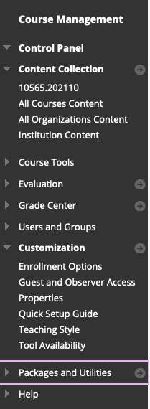

- Scroll to Set Course Duration and enter dates you want:
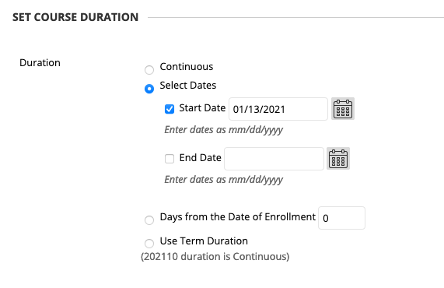

- Click Submit. This will change when your students can view the course.

