How to edit a document from the content collection
- Go to Content Collection on the course menu and click on the course name.
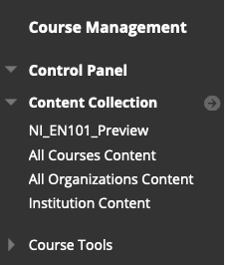
- Click on course_files.
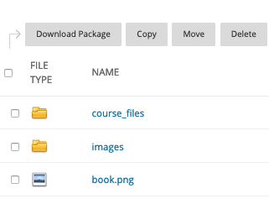
- Locate the appropriate folder. The course schedule is in the docs folder.
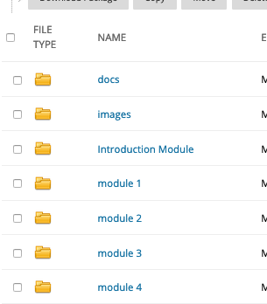
- Select the .docx file you want to edit and download it to your computer. Make the changes you want on the document. Save the file as both a .docx and a .pdf.
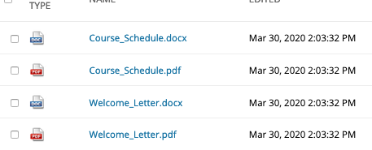
- After you have made your edits and saved the new file to your computer, you are ready to insert it back into the course. Click the box next to the file you want to replace and select Overwrite File. Do the same for the .pdf version.
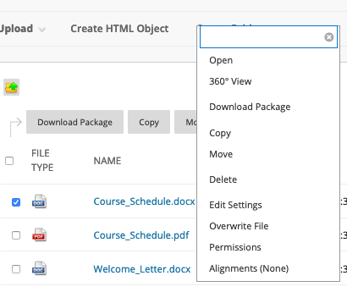
- Check the appropriate content area in the course to verify that your new document now appears.
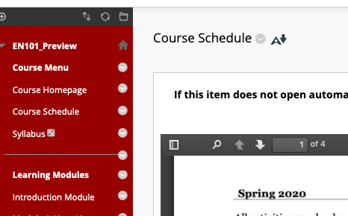
- To edit an assignment sheet, follow the same steps within the appropriate module.
